PO4.Mascots

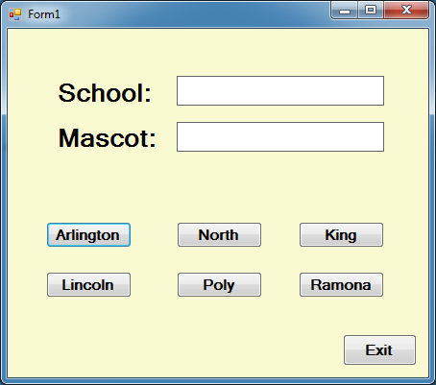

Private Sub btn1_Click(sender As System.Object, e As System.EventArgs) Handles Button1.Click

lblDisplay1.Text = "Arlington"

lblDisplay2.Text = "Lions"

End Sub

Private Sub btn2_Click(sender As System.Object, e As System.EventArgs) Handles Button2.Click

lblDisplay1.Text = "North"

lblDisplay2.Text = "Huskies"

End Sub

Private Sub btn3_Click(sender As System.Object, e As System.EventArgs) Handles Button3.Click

lblDisplay1.Text = "King"

lblDisplay2.Text = "Wolves"

End Sub

Private Sub btn4_Click(sender As System.Object, e As System.EventArgs) Handles Button4.Click

lblDisplay1.Text = "Lincoln"

lblDisplay2.Text = "Panthers"

End Sub

Private Sub btn5_Click(sender As System.Object, e As System.EventArgs) Handles Button5.Click

lblDisplay1.Text = "Poly"

lblDisplay2.Text = "Bears"

End Sub

Private Sub btn6_Click(sender As System.Object, e As System.EventArgs) Handles Button6.Click

lblDisplay1.Text = "Ramano"

lblDisplay2.Text = "Rams"

End Sub

Private Sub btnExit_Click(sender As System.Object, e As System.EventArgs) Handles btnExit.Click

Application.Exit()

End Sub

End Class